### AY2018 Semester 2

|  |  |  |  |
| --- | --- | --- | --- |
| Name |  | | |
| Student ID |  | | |
| Assessment Venue |  | Seat Number |  |

**E331 ESE**



E331 Supply Chain Management

**AY2018 Semester 2 End-Semester Examination (ESE)**

**Instructions to student:**

|  |  |  |
| --- | --- | --- |
| ***This segment is to be used by staff grader(s) only.*** | | |
| **Question Number** | **Marks Awarded** | **Max Marks** |
| **1** |  | **10** |
| **2** |  | **20** |
| **3** |  | **12** |
| **4** |  | **11** |
| **5** |  | **15** |
| **6** |  | **15** |
| **7** |  | **10** |
| **8** |  | **7** |
|  |  |  |
|  |  |  |
|  |  |  |
|  |  |  |
|  |  |  |
|  |  |  |
|  |  |  |
|  |  |  |
| **Total** |  | **100** |

## Do not turn over this question paper until you are instructed to do so by the invigilator.

1. Write your name, student ID, assessment venue and seat number in the table provided at the top of each page.
2. For this question paper, there are **18** pages (including this cover page).
3. For this assessment, you are allowed to:
   * Refer to materials stored in your laptop.
   * Have only one set of hardcopy notes in bound form, and no larger than A4 size
   * Have a blank piece of paper for rough working purpose. (Note that the sheet of rough working paper will not be accepted for submission at the end of the assessment.)
4. For this assessment, you are **NOT** allowed to:
   * Refer to written materials including textbooks and hardcopy notes in loose form or larger than A4 size.
   * Share any material, such as calculators, with another student.
   * Communicate with any person other than the invigilator.
   * Use any communication devices such as handphone or smart watches while at the assessment venue.
5. All rules and regulations pertaining to summative assessments and academic integrity stated in the Student Handbook shall also apply.

|  |  |  |
| --- | --- | --- |
| ***This segment is to be used by the invigilator only and for ‘online’ and ‘online and paper’ mode assessments only*** | | |
| Please tick the box below if the  student has done part of the assessment online: | Invigilator’s Name: | Invigilator’s Signature: |
| Partially done online |  |  |

Page 1 of 18

**Question 1 [10 Marks]**

### Multiple Choice Question (only ONE answer is required to be written in the box provided)

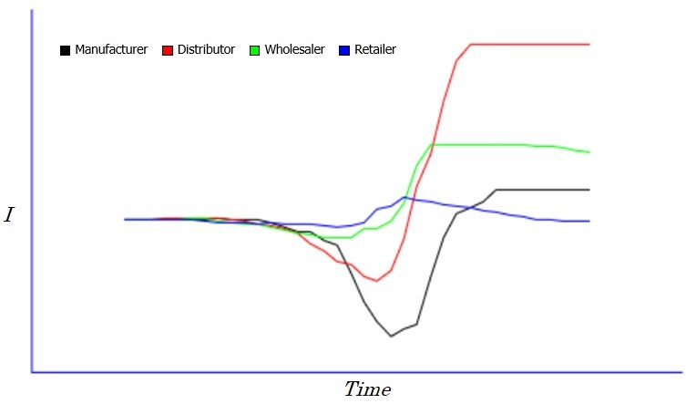

Figure 1.1 Inventory Level over Time

1. Figure 1.1 illustrates the Bullwhip Effect on the inventory level of various supply chain parties over time. Which following statement can you make on the Distributor’s inventory level? (1 mark)
   1. There was competition for same inventory with the other parties
   2. The inventory level dropped initially and rose subsequently
   3. The inventory safety stock level was inaccurate
   4. There was a lot of inventory loss
   5. There was no inventory
2. Which of the following is NOT a potential cause for the Bullwhip Effect? (1 mark)
   1. Over reacting to out of stock situation
   2. Lengthy order fulfilment lead time
   3. Insufficient safety stock
   4. Inaccurate forecast
   5. Market competition
3. Which of the following describes the key role played by the supply chain control tower to minimise the Bullwhip Effect? (1 mark)
   1. Provide visibility and real time order information across supply chain
   2. Support centralization and decentralization of supply chain facilities
   3. Optimise number of facilities and routes
   4. Reduce total transportation costs
   5. Maximise safety stock
4. The followings are all the SCOR model’s Level-1 management processes except one. Which one is NOT? (1 mark)
   1. Plan
   2. Source
   3. Make
   4. Deliver
   5. Repair
5. Identify the incorrect SCOR model’s performance attribute from the following. (1 mark)
   1. Reliability
   2. Responsibility
   3. Agility
   4. Costs
   5. Assets
6. Which of the followings is NOT a factor influencing the decision on plant location.

(1 mark)

* 1. Population
  2. Strategic
  3. Technology
  4. Macroeconomic
  5. Infrastructure

1. The Capacitated Plant Location Model can determine the location and capacity allocation of plant or facility using . (1 mark)
   1. VBA programming
   2. Python programming
   3. Rigorous programming
   4. Integer programming
   5. Java programming
2. The considerations for designing distribution network is to meet customer needs while managing the associated of meeting these needs. (1 mark)
   1. Processes
   2. Costs
   3. Risks
   4. Operations
   5. Technologies
3. Which of the followings is NOT an important player in Humanitarian logistics. (1 mark)
   1. Disaster Response Team
   2. Government
   3. Small Medium Enterprise
   4. Logistic Service Provider
   5. Media
4. Which of the followings might NOT be a logistics challenge during a humanitarian operations? (1 mark)
   1. Lack of equipment
   2. Limited warehouse space
   3. Short of skilled local staff
   4. Language barrier
   5. Damaged infrastructure

# Question 2 [20 Marks]

Samson is a new smart phone brand in an extremely competitive market. They have been very successful in the launch of their new phone model in Asia and now they plan to expand into the US market. They have engaged a consultancy firm to help make decision on the distribution network design model for US. Table 2.1 and 2.2 below are the results of the quantitative analysis using simple scoring method.

Table 2.1 Product Characteristics and Customer Preferences

|  |  |  |  |  |  |  |  |
| --- | --- | --- | --- | --- | --- | --- | --- |
|  | | **Retail Storage with Customer Pickup** | **Manufacturer Storage with Direct Shipping** | **Manufacturer Storage with Merge In-**  **Transit** | **Distributor Storage**  **with Package Carrier**  **Delivery** | **Distributor Storage**  **with Last Mile Delivery** | **Manufacturer**  **/Distributer Storage with Customer Pickup** |
| **Product Characteristics** | **High Demand**  **Product** | **2** | **-2** | **-1** | **0** | **1** | **-1** |
| **Medium Demand**  **Product** | **1** | **-1** | **0** | **1** | **0** | **0** |
| **Low Demand**  **Product** | **-1** | **1** | **0** | **1** | **-1** | **1** |
| **Very Low**  **Demand Product** | **-2** | **2** | **1** | **0** | **-2** | **1** |
| **Many Product**  **Sources** | **1** | **-1** | **-1** | **2** | **1** | **0** |
| **High Product**  **Value** | **-1** | **2** | **1** | **1** | **0** | **-2** |
| **Customer Preferences** | **Quick Desired**  **Response** | **2** | **-2** | **-2** | **-1** | **1** | **-2** |
| **High Product**  **Variety** | **-1** | **2** | **0** | **1** | **0** | **2** |
| **Low Customer**  **Effort** | **-2** | **1** | **2** | **2** | **2** | **-1** |
|  | **Total Score** | **1** | **-2** | **0** | **2** | **3** | **-3** |

Table 2.2 Customer Services and Supply Chain Costs

|  |  |  |  |  |  |  |  |
| --- | --- | --- | --- | --- | --- | --- | --- |
|  | | **Retail Storage with Customer Pickup** | **Manufacturer Storage with Direct Shipping** | **Manufacturer Storage with Merge In-**  **Transit** | **Distributor Storage**  **with Package Carrier**  **Delivery** | **Distributor Storage**  **with Last Mile Delivery** | **Manufacturer**  **/Distributer Storage with Customer Pickup** |
| **Customer Services** | **Response Time** | **1** | **4** | **4** | **3** | **2** | **4** |
| **Product Variety** | **4** | **1** | **1** | **2** | **3** | **1** |
| **Product**  **Availability** | **4** | **1** | **1** | **2** | **3** | **1** |
| **Customer**  **Experience** | **5** | **4** | **3** | **2** | **1** | **5** |
| **Order Visibility** | **1** | **5** | **4** | **3** | **2** | **6** |
| **Returnability** | **1** | **5** | **5** | **4** | **3** | **2** |
| **Supply Chain Cost** | **Inventory** | **4** | **1** | **1** | **2** | **3** | **1** |
| **Transportation** | **1** | **4** | **3** | **2** | **5** | **1** |
| **Facility &**  **Handling** | **6** | **1** | **2** | **3** | **4** | **5** |
| **Information** | **1** | **4** | **4** | **3** | **2** | **5** |
|  | **Total Score** | **18** | **19** | **19** | **17** | **15** | **22** |

1. Based on Total Score, which **TWO (2)** designs in Table 2.1 would you shortlist for consideration? Why? (3 marks)

Distributor Storage with Last Mile Delivery and Distributor Storage with Package Carrier Delivery. This is because based on the scores, the higher the scores the more suitable the network design. Conclusively, Distributor Storage with Last Mile Delivery scores 3 and Distributor Storage with Package Carrier Delivery scores 2 which are the highest scores indicating they are the most suitable.

1. Based on the Total Score in Table 2.2, which design would be your best choice? Why?

(2 marks)

Distributor Storage with Last Mile Delivery and Distributor Storage with Package Carrier Delivery. This is because based on the scores, the lower the scores the stronger performance of the network design. Conclusively, Distributor Storage with Last Mile Delivery scores 15 and Distributor Storage with Package Carrier Delivery scores 17 which are the highest scores indicating they are the most suitable.

1. For Asian markets, Samson recently reviewed their supply chain performances and Table 2.3 below shows the SCORcard from their benchmarking analysis.

Table 2.3 SCORcard

|  |  |  |  |  |  |  |
| --- | --- | --- | --- | --- | --- | --- |
|  | | | | **Industry Benchmarks** | | |
|  | **Performance**  **Attributes** | **SCOR Level-1**  **Metric** | **Actual** | **Parity** | **Advantage** | **Superior** |
| **External** | **Reliability** | **Delivery**  **Performance** | 90% | 90% | 94% | 98% |
| **Fulfilment Rate** | 96% | 94% | 96% | 98% |
| **Pefect Order** | 99% | 90% | 95% | 99% |
| **Responsiveness** | **Fulfilment Lead**  **Time** | 5 Days | 7 Days | 5 Days | 3 Days |
| **Response Time** | 20 Days | 60 Days | 40 Days | 20 Days |
| **Flexibility** | **Production**  **Flexibility** | 35 Days | 30 Days | 25 Days | 20 Days |
| **Internal** | **Costs** | **Fulfilment Cost** | 15% | 15% | 10% | 5% |
| **MRO Cost** | 3% | 3% | 2% | 1% |
| **Assets** | **Inventory Days**  **of Supply** | 45 Days | 35 Days | 28 Days | 21 Days |
| **Cash to Cash**  **Cycle Time** | 65 Days | 60 Days | 45 Days | 30 Days |

Name the SCOR Level-1 Metric from Table 2.3 for the following questions respectively.

* 1. **THREE (3)** Metrics that show Samson is on par with industry. (3 marks)

Delivery Performance, Fulfilment Cost, MRO Cost

* 1. **TWO (2)** Metrics that show Samson is in favourable position. (2 marks)

Fulfilment Rate, Fulfilment Lead Time

* 1. **TWO (2)** Metrics that show Samson is best in class. (2 marks)

Perfect Order, Response Time

* 1. **THREE (3)** Metrics that show Samson needs improvement. (3 marks)

Production Flexibility, Inventory Days of Supply, Cash to Cash Cycle Time

1. To reduce inventory level, Samson reviewed their supply chain processes. Figure 2.1 shows the SCOR Level-2 process flow gathered from several review sessions.

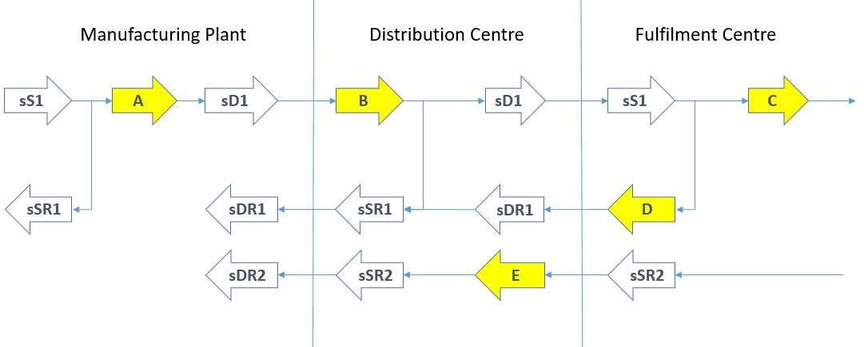

Figure 2.1 SCOR Level-2 Process Flow

Name the Level-2 processes labelled with A, B, C, D and E. (5 marks)

A: sM1

B: sS1

C: sD1

D: Ssr1

E: Sdr2

# Question 3 [12 Marks]

Dieson is a popular brand of printing machines. The company has its own research and development centre on printing technologies with several manufacturing and distribution facilities worldwide to meet global demands.

1. One factory in Hamburg, Germany which mainly manufactures new products is usually the first factory to implement the new production process and technology before other factories.

i What is the strategic role of this factory in Hamburg for Dieson? (1 mark)

Lead Facility: Facility that leads in development and process

technologies

ii Besides rich technological resources in Hamburg, give **ONE (1)** other factor for the strategic role you mentioned in question i). (1 mark)

One other essential factor is the accessibility to a skilled workforce/

1. As Dieson expands its manufacturing network to other countries, due to its product variety (poster printers, home printers, pocket printers, etc.), the company set up different factories to specialise in different products.
   1. In term of macroeconomic factor, identify **ONE (1)** risk that Dieson may face by operating in this way. (1 mark)

Exchange rate risks: This risk arises from the fact that companies might incur their costs in one currency and collect their revenues in other currencies.

* 1. Suggest **ONE (1)** strategy to mitigate the risk you mentioned in question i). Explain how the strategy can reduce the risk. (3 marks)

Potential protection to exchange rate risk: Build some flexible overcapacity to the regional facilities so that production is shifted to the lower-cost regions.

1. Dieson has a regional distribution centre in Singapore and Hong Kong respectively. If it chooses to combine a product’s inventory into one of these warehouses, how would the inbound transportation cost and outbound transportation change for this product?

(2 marks)

As we reduce the number of warehouses (centralized system), the outbound transportation costs (costs incurred for delivering the items from warehouses to the customers) increase, while the inbound transportation costs (costs of shipping the products from the suppliers and manufacturing facilities to the warehouses) decrease.

1. Dieson decided to combine a product’s inventory into either Singapore or Hong Kong warehouse in view of its high inventory level in these 2 warehouses. The product’s demand information is presented in Table 3.1 below.

Table 3.1 Average Monthly Demand and Standard Deviation

|  |  |  |
| --- | --- | --- |
| **Warehouse** | **Average Monthly**  **Demand** | **Standard Deviation of**  **Monthly Demand** |
| **Singapore** | 200 | 12.0 |
| **Hong Kong** | 300 | 18.0 |
| **Combined** | 500 | 30.0 |

Is it worth to combine the product’s inventory into one warehouse? Justify your answer.

(4 marks)

This can be proven using the coefficient of variation (COV) is the ratio of the standard deviation to the mean. COV is simply a measure of dispersion of the variable. The advantage of using the COV is that it can compare across different variables because they are now measured on the same relative scale (ratio).

Singapore’s COV = Standard Deviation/Mean

= 12/200

= 0.06

Hong Kong’s COV = Standard Deviation/Mean

= 18/300

= 0.06

Combined COV = Standard Deviation/Mean

= 30/500

= 0.06

The higher the coefficient of variation, the greater the benefit obtained from centralized system, that is, the greater the benefit from risk pooling. Hence, it is not worth to combine the product’s inventory into one warehouse.

# Question 4 [11 Marks]

Hockers is a manufacturer and distributor of various men’s fashion apparels in South East Asia. With the increasing trend of their competitors embarking on green supply chain, Hockers is also considering and exploring going green with its supply chain.

1. List **THREE (3)** benefits that Hockers can gain from greening its supply chain.

(3 marks)

Positive impact on financial performance

Sustainability of resources

Lowered operational costs/increased efficiency

1. List **TWO (2)** types of output which have harmful environmental impacts from the Hockers’ supply chain activities. (2 marks)

Solid Waste, Water Waste.

1. Fill in the blanks in the following statement: (4 marks)

Hockers tries to minimize negative environmental impacts of a product and its **i)** packagingthroughout its life cycle. Thus, during the phase of product design, Hockers has already considered the product disposal because some products emit **ii)** dangerous chemicals into the ground after landfill. Moreover, Hockers decides to work together with its vendors to ensure there is no agro-chemicals in the **iii)** entire manufacturingprocess from raw fiber to textile. Meanwhile, Hockers also encourages **iv)** the use of eco-friendly of raw materials bought from its vendors.

1. Hockers wants to change its production process from straight push to pull, push-pull or postponement strategy. Explain how this change will help to green the supply chain?

(2 marks)

Initiatives under the production function would include improving the factory layout, utilizing fuel efficient tools & machines, recycling materials and improving the production process from straight push to pull, push-pull, or postponement strategy. This would reduce in-house traffic movement, reduce finished goods inventory & warehouse space and improve fuel efficiency.

# Question 5 [15 Marks]

Atlantis Pte Ltd., a local stock exchange listed SME, has just released the company’s financial report for Financial Year (FY) 2018. The following Table 5.1, 5.2 and 5.3 contain extracts of information from the financial report.

Table 5.1 Extracted Information for FY 2018

|  |  |  |  |  |  |
| --- | --- | --- | --- | --- | --- |
| **Net sales** | **COGS** | **Inventory** | **Account Receivable** | **Account Payable** | **Operating Profit** |
| $9,114,000 | $3,534,000 | **A** | $1,926,000 | $604,000 | $3,000,000 |

Table 5.2 Result of the Cash-To-Cash (C2C) Cycle Time (in days)

|  |  |  |  |
| --- | --- | --- | --- |
| **Inventory Days of Supply** | **Days Sales Outstanding (DSO)** | **Average Payment Days** | **Cash to Cash (C2C) Cycle Time** |
| 71.1 | **B** | 62.4 | 85.8 |

Table 5.3 Summary of the Balance Sheet of FY 2018

|  |  |  |  |  |  |  |
| --- | --- | --- | --- | --- | --- | --- |
| **Current Assets (A1)** | **Non-Current Assets (A2)** | **Total Assets (A1+A2)** | **Current Liabilities (L1)** | **Non-Current Liabilities (L2)** | **Total Liabilities (L1+L2)** | **Total Equity** |
| $3,350,000 | $12,500,000 | $15,850,000 | $1,340,000 | $11,250,000 | $12,590,000 | $3,260,000 |

1. Calculate the value of “**A**” in Table 5.1 above. Show your working. (3 marks)

In this case regarding the inventory, the missing number A is the average inventory.

Inventory days of supply = (Average inventory/cost of goods sold) * 365

71.1 = Average Inventory/3534 * 365

Average Inventory = 71.1/365 * 3534

= 688.40 (Round to 2d.p)

1. Calculate the value of “**B”** in Table 5.2 above. Show your working and keep all numbers in the calculation to 1 decimal place. (3 marks)

In this case regarding Days Sales Outstanding, the missing number B is also known as the Accounts Receivable (A/R) days.

Accounts Receivable (A/R) days = (A/R/Net Sales) * 365

= (1926/9114)*365

= 78 days (Round Up to Next Whole Number)

1. Name the financial measure which indicates how profitable a company's assets are in generating revenue. (1 mark)

Return On Assets (ROA)

1. Calculate the Return on Capital Employed (ROCE) of FY2018. What does a high ROCE indicate? Show your working and keep all numbers to 2 decimal places. (4 marks)

Capital Employed = Total Assets – Current Liabilities

= 15850-1340

= 14510

ROCE = Operating Profit / Capital Employed

= 3000/14510

= 0.21 (Rounded to 2d.p)

A A A higher ROCE indicates more efficient use of capital. ROCE should be higher than the company's capital cost; otherwise, it indicates that the company is not employing its capital effectively and is not generating shareholder value.

1. Apart from Balance Sheet, name the financial statement that helps investors assess whether the company made or lost money for the financial year. (1 mark)

Profit & Loss Account (P&L)

1. The company found out that the C2C for one of their competitors is 20 days. What does that mean? Who perform better in terms of C2C? Explain. (3 marks)

The cash to cash cycle is the time period between when a business pays cash to its suppliers for inventory and receives cash from its customers. In this case, this outcome states that their competitor’s business must support its expenditures for a period of 20 days.

Since the company’s Cash to Cash (C2C) Cycle Time is 85.8 days which is much more than 20 days, their competitors are doing far better than them since it indicates that their competitors are 65.8 days of a faster inventory-to-sales process.

# Question 6 [15 Marks]

Tesar, an automotive vehicle maker, has a production plant in rural Thailand and a regional warehouse in Bangkok’s suburb area. In each of these facilities, designated areas were reserved to store finished products and the assembly parts. The company produces 2 models of vehicle – Sedan and Hatchback. They sell these models of vehicles through channel of distributors and dealers across the region. The company has just implemented a new SAP system as part of the company’s long term strategies. (The following questions are related to the SAP Sales and Distribution (SD) module.)

1. Based on the description above, name the “Distribution Channels” and “Divisions” for the vehicles. (5 marks)

Distribution Channels: Distributors and dealers across the region

Divisions: Sedan and Hatchback

1. T1 and T2 are both subsidiaries of Tesar. T1 places the orders and T2 receives the goods while the invoices are sent to Tesar. Tesar pays for all orders placed by its subsidiaries. Fill in the blanks in the following table. (4 marks)

|  |  |
| --- | --- |
| **Partner function** | **Company Name** |
| Sold-to | T1 |
| Ship-to | T2 |
| Bill-to | Tesar |
| Payer | Tesar |

1. Figure 6.1 below is a SAP screenshot showing the document flow for a sale order (0000012751) created by Tesar’s Sales Department (T1). Based on this document flow,
   1. Which step is this sales order at? (2 marks)

The Billing Process.

* 1. Explain your answer. (2 marks)

This is because in Figure 6.1, the Document Flow indicates that the accounting document has not been cleared by the FICO staff; which stands for (Financial Accounting) and CO (Controlling). This most likely means awaiting the payment from customer before they can clear it.

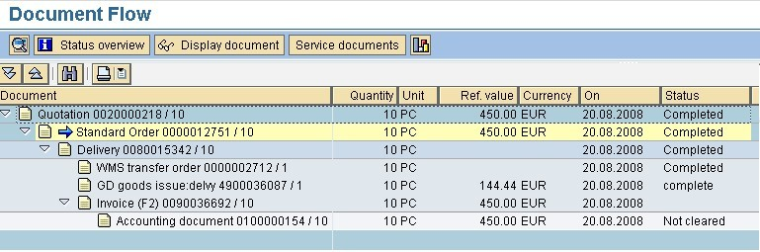

Figure 6.1 SAP screenshot

1. What is the unit selling price (in EUR) according to the above document flow for this sales order? (2 marks)

Unit Selling Price = 450/10

= 45

# Question 7 [10 Marks]

Himalaya Pte Ltd is a distributor of dairy products in Singapore. Their customers are mostly supermarkets and convenient stores. The company has been using direct shipment but their transportation manager is now considering Milk Run for the delivery route.

1. With the information given in Figure 7.1, what is the distance saved from changing Direct Shipment to Milk Run? Show your working. (3 marks)



A

B

WH

C

|  |  |  |  |  |
| --- | --- | --- | --- | --- |
| **Distance (KM)** | **WH** | **A** | **B** | **C** |
| **WH** | 0 |  |  |  |
| **A** | 2 | 0 |  |  |
| **B** | 2 | 3 | 0 |  |
| **C** | 2 | 3 | 3 | 0 |
| **WH – Warehouse A, B, C – Customer** | | | | |

Figure 7.1 Himalaya Warehouse to Customers

Total of all Individual runs using Direct Shipment to Milk Run:

(WH to A to WH, WH to B to WH, WH to C to WH) = 2*2+2*2+2*2

= 12

Direct Shipment using Milk Run:

(WH to A to B to C to WH) = 2+3+3+2

= 10

Hence, a total distance of 2 derived from 12-10 is saved.

1. After implementing the Milk Run, the transportation manager wants to use Saving Matrix Method to plan his route. The distance savings matrix from its warehouse to all the customers and between all customers and order size for each customer are given in Table

7.1. Right now Himalaya has 3 refrigerated trucks with 100 boxes capacity for each truck.

Table 7.1 Distance Savings Matrix and Customer Order Size

|  |  |  |  |  |  |  |  |
| --- | --- | --- | --- | --- | --- | --- | --- |
| **Distance Savings Matrix (in km)** | | | | | | | **Order Size (in boxes)** |
|  | **C1** | **C2** | **C3** | **C4** | **C5** | **C6** |  |
| **C1** | **0** |  |  |  |  |  | **38** |
| **C2** | **13** | **0** |  |  |  |  | **53** |
| **C3** | **10** | **6** | **0** |  |  |  | **73** |
| **C4** | **11** | **12** | **14** | **0** |  |  | **29** |
| **C5** | **8** | **9** | **11** | **6** | **0** |  | **32** |
| **C6** | **7** | **11** | **9** | **12** | **7** | **0** | **36** |

Identify the best saving routes for all the trucks. Calculate the total loadings for each route, assuming one truck takes one route. (7 marks)

First Trial: C2 to C3, C2 to C3 distance savings of 17km, 53+73 = 126 Boxes out of 100 box capacity, Limit Exceeded so it is not applicable

Second Trial: C4 to C5, C4 to C5 distance savings of 12km, 29+32 = 61 Boxes out of 100 box capacity, Limit not Exceeded so it is applicable

Third Trial: C1 to C4 to C5, C1 to C4 distance savings of 12km, 38+29+32 = 99 Boxes out of 100 box capacity, Limit not Exceeded so it is applicable

Hence, the first confirmed truck’s route is from C1 to C4 to C5 to C1 with a truck capacity of 99 out of the allowed 100 boxes. The actual distance of the entire route is 11+6+8 = 25km.

Since the First Trial I calculated earlier of C2 to C3 exceeded, the only way is to split these two deliveries into two different Trucks. C6 has not been assigned a truck so it will be assigned with C2 since C2 and C6 combined capacity is within the box capacity limit, 53+36= 89.

Hence, the second confirmed truck’s route is from C1 to C2 to C6 to C1 with a truck capacity of 53+46 = 89 out of the allowed 100 boxes. The actual distance of the entire route is 13+11+7 = 31km.

Hence, the third confirmed truck’s route is from C1 to C3 to C1 with a truck capacity of 73 out of the allowed 100 boxes. The actual distance of the entire route is 10+10 = 20km.

# Question 8 [7 Marks]

Hope Logistics is a humanitarian logistic company based in Singapore. As they have been very experience in humanitarian logistic operations in South East Asia, they are usually one of the first organisation to respond to call for emergency disaster response and relief support in the region.

1. There are many challenges that Hope Logistics would face during their operations on sites. Give **TWO (2)** examples that are related to poor and unpredictable operating conditions (2 marks)

Poor or Dangerous Weather conditions and the extent of the damage on infrastructure.

1. Name **TWO (2)** of the 4 phases of disaster management cycle. (2 marks)

Recovery phase and Mitigation phase

1. From the operations context, what are the **THREE (3)** aspects that Hope Logistics would need to consider in any disaster response and relief project? (3 marks)

Humanitarian Context

SCM in the Humanitarian Context

Role of SCM in the Humanitarian Context

### --------------------- END OF PAPER ---------------------